EXHIBIT B
ACH DEBIT AUTHORIZATION
THIS EXHIBIT B IS NOT APPLICABLE
AUTHORIZATION AGREEMENT FOR DIRECT PAYMENTS (ACH DEBITS)

Company Tax
Name ID Number
I (we) hereby authorize Wal-Mart Stores, Inc., hereinafter called COMPANY, to initiate debit entries to my (our) Checking Account / Savings Account (select one) indicated below at the depository financial institution named below, hereinafter called DEPOSITORY, and to debit the same to such account. I (we) acknowledge that the origination of ACH transactions to my (our) account must comply with the provisions of U.S. law.

Depository
Name: Branch
City State Zip

Routing Account
Number Number

This authorization is to remain in full force and effect until COMPANY has received written notification from me (or either of us) of its termination in such time and in such manner as to afford COMPANY and DEPOSITORY a reasonable opportunity to act on it.

Name (s) Tax ID Number
(Please Print)

Date Signature

NOTE: ALL WRITTEN DEBIT AUTHORIZATIONS MUST PROVIDE THAT THE RECEIVER MAY REVOKE THE AUTHORIZATION ONLY BY NOTIFYING THE ORIGINATOR IN THE MANNER SPECIFIED IN THE AUTHORIZATION.

ADDITIONAL INFORMATION REQUIRED: (Please Print)

TENANT NAME

CONTACT NAME

PHONE #

FAX #

E-MAIL ADDRESS

*You will receive a detail listing each month 3-5 days before your account is debited. Please review this information for accuracy and let our Asset Managers Debbie Klossner, at 479 204-0011 or Carolyn Milliron at 479-273-8161, know promptly of any discrepancies you discover. We will then make the appropriate corrections to ensure the correct amount is debited form your account. We will Fax the detail listing to you each month so please make sure to provide us the Fax # of the responsible party/department in your organization.

EXHIBIT C-1

TENANT’S STANDARD INTERIOR BULKHEAD SIGNAGE
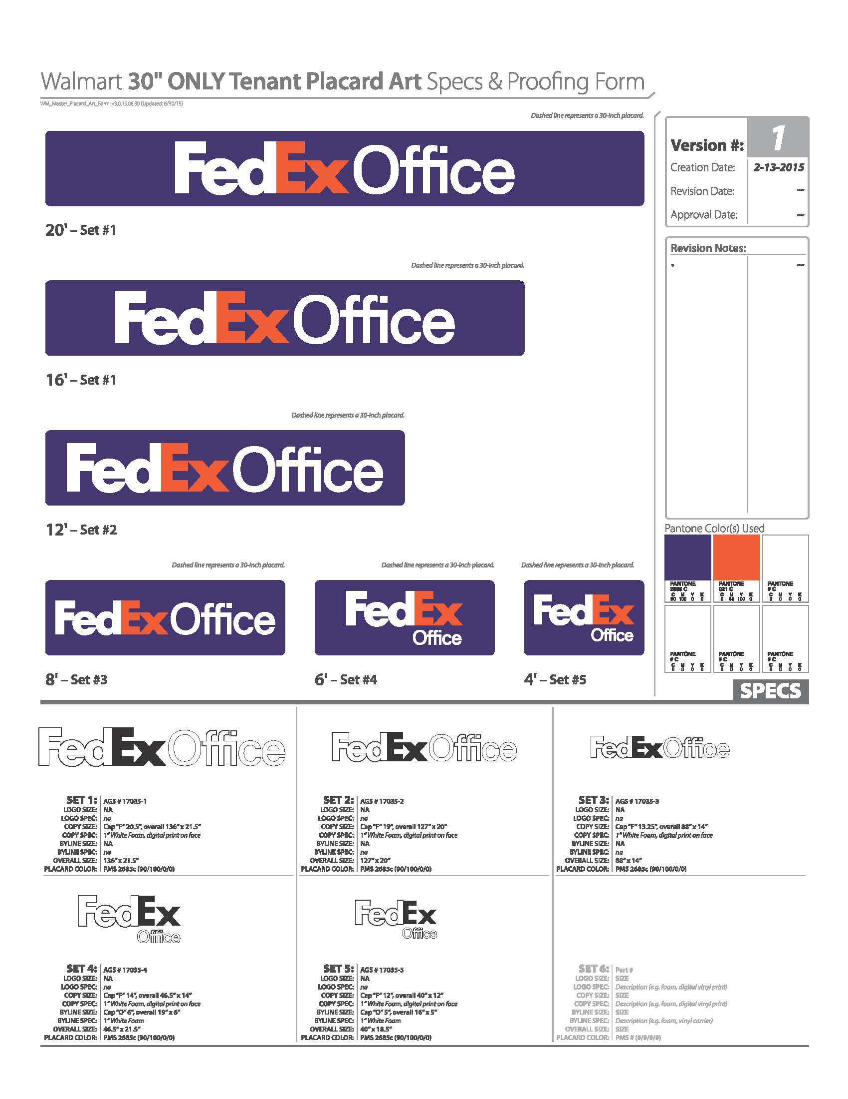
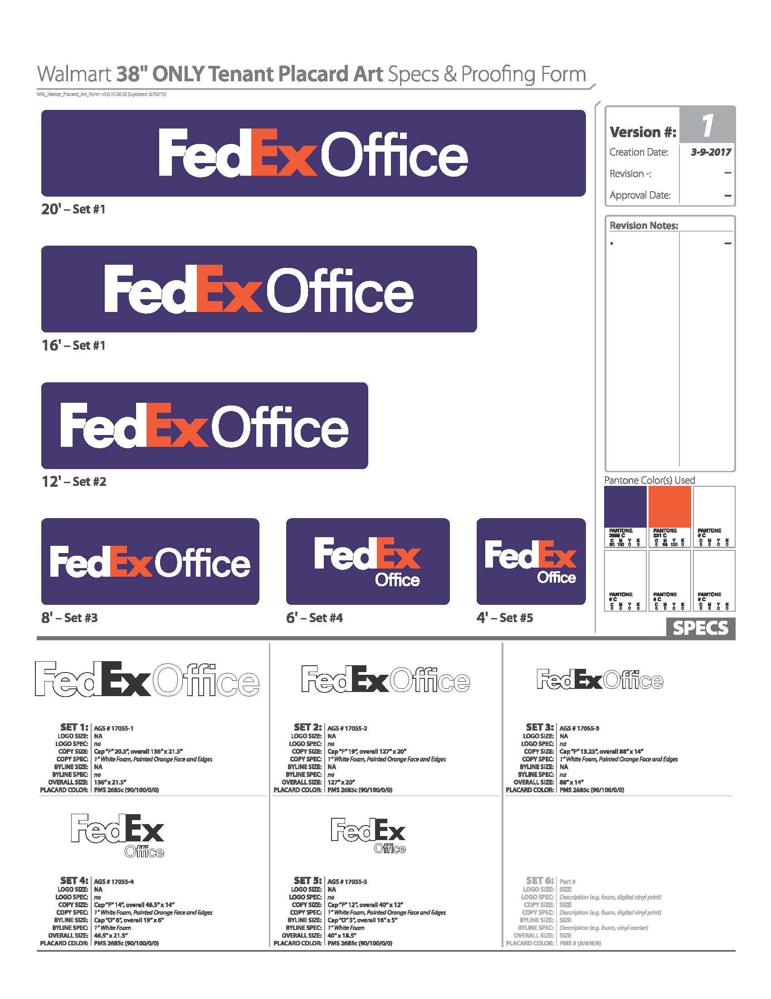

EXHIBIT C-2

TENANT’S STANDARD EXTERIOR SIGNAGE

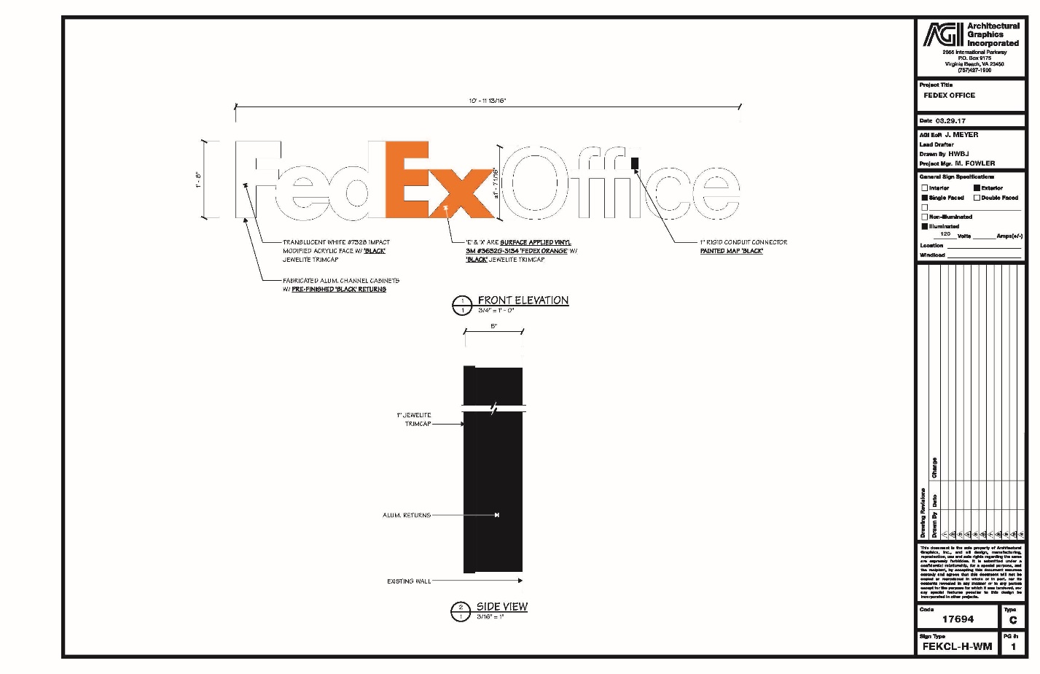
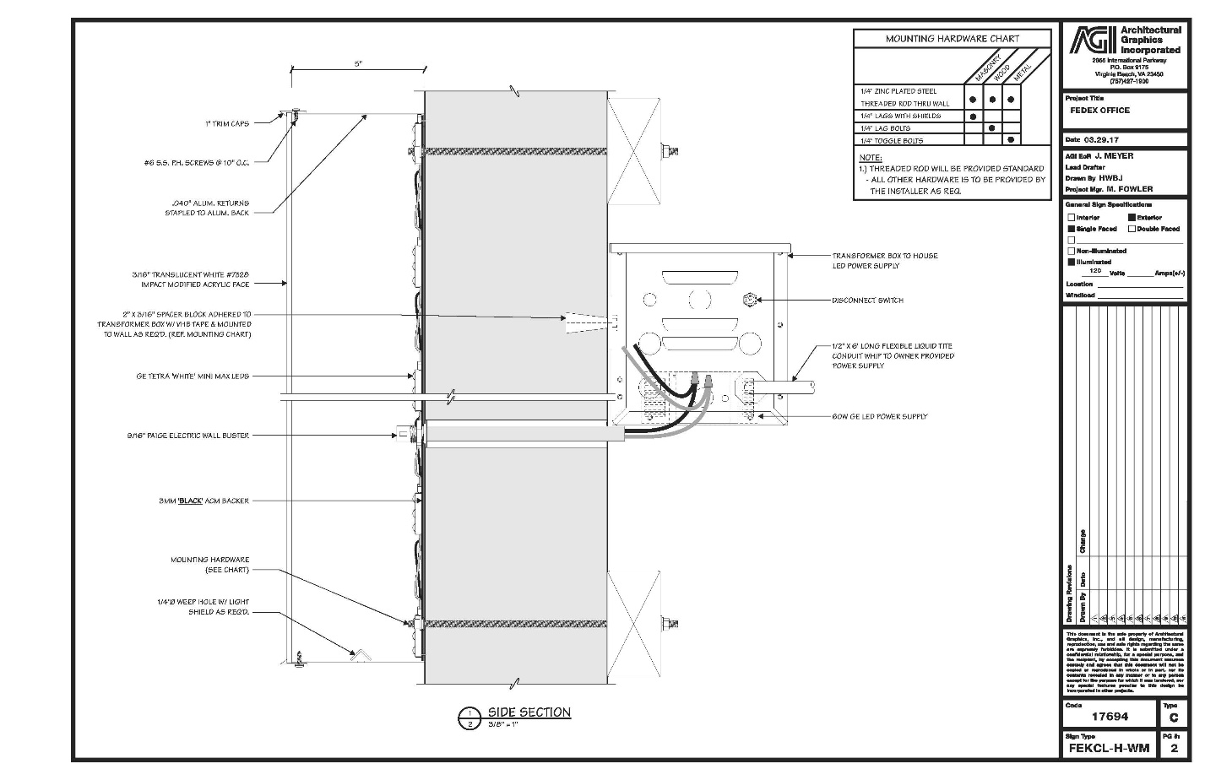

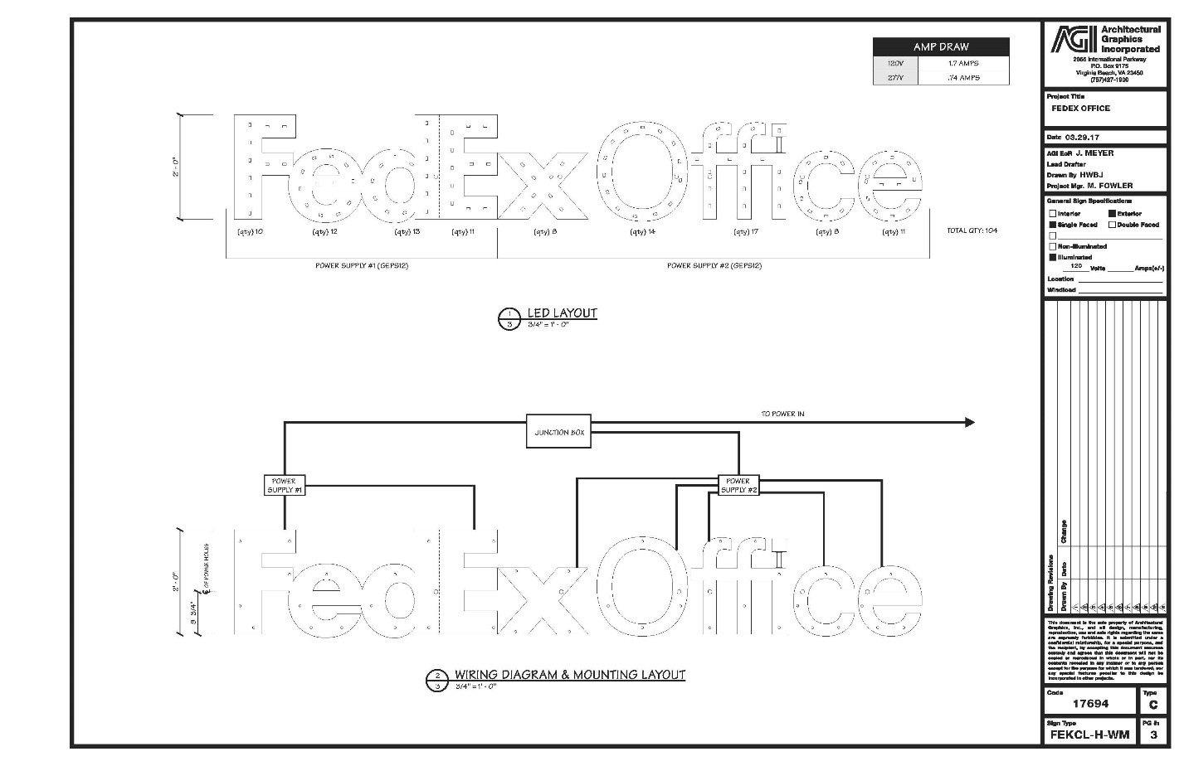

EXHIBIT D
LANDLORD’S WORK

[DESCRIBE WORK, IF ANY]

~144~
EXHIBIT E
BASE RENT AND PERCENTAGE RENT
DURING EXTENSION TERM(S)

Base Rent. During the Extension Term, Base Rent shall be increased to: $500/month.
Percentage Rent. During the Extension Term, the chart set forth in Article IV, Section 3 of this Attachment A, shall be updated as follows:
Percentage Rent Rate | Net Revenue Thresholds
6% | of that portion of the annual Net Revenue for the applicable Lease Year that is less than Fifty Thousand Dollars ($50,000.00)
10% | of that portion of the annual Net Revenue for the applicable Lease Year that is greater than or equal to Fifty Thousand Dollars ($50,000.00) but is less than Seventy Five Thousand Dollars ($75,000.00)
12% | of that portion of the annual Net Revenue for the applicable Lease Year that is greater than or equal to Seventy Five Thousand Dollars ($75,000.00)

