Direct Deposit Authorization Form

Please print and complete ALL the information below.
Name: | John Doe
Address: | 29 Elm St
City, State, Zip: | Ronkonkoma, 11779
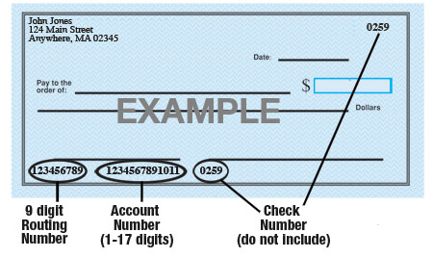

Name of Bank: /e1_________________________________________________________

Account #: /e2_________________________________________________________

9-Digit Routing #: /e3_________________________________________________________

Amount: ◻ $ ____________ ◻ ___________%  or ◻ Entire Paycheck

Type of Account: ◻ Checking ◻ Savings (Check One)

Attach a voided check for each bank account to which funds should be deposited (if necessary)

Juiced Technologies is hereby authorized to directly deposit my pay to the account listed above. This authorization will remain in effect until I modify or cancel it in writing.

Employee’s Signature: /e4___________________________________________________

Date: /e5________________________

