ISO 9001:2015

Certificate of Registration
for
Mooring Manufacturing LLC
240 Jupiter Street, Jupiter, Florida 33458

International Auditors Inc. certifies that the Management System of the above organization has been independently assessed and is compliant with the requirements of:

ISO 9001:2015
Scope of Certification:
Provide Flood Protection Solutions for organizations throughout North America.
Out of Scope: Clauses 7.1.5 and 8.5.3

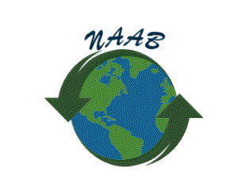
Certificate Registration No. :IAI-Q-190200002
Date of Original Certification : 22 February 2019
Surveillance audit on or prior : 21 February 2020
Certificate Expiry on : 21 February 2020
Recertification due prior : 21 February 2022

This certificate is the property of International Auditors Inc and remains valid subject to satisfactory annual surveillance audits.

Scott A. Bullock
President
International Auditors Inc.

