Feature Comparison | 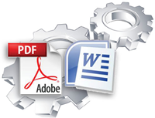  Exact Forms Plus! | 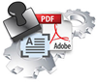  PDF Stamper
Template File Type | doc, docx | PDF
Output File Type | doc, docx or PDF | PDF
Handles application tokens
Store output file in QuickBase
Handles images and barcodes
Captures creation date in QuickBase
Integrates with Courier for QuickBase
Integrates with DocuSign for QuickBase
Can include "Subtable" or "Related" data
Handles text fields with embedded HTML tags
Store output file in Amazon S3
Store output file in separate "Repository" table
Create password protected files
Create multiple DOC and PDF files with a single button click | * | **
Create merged PDF files from multiple record transaction
Merged additional PDF files into Output File

This is the first release for PDF Stamper so these features are not available at this time. The PDF Stamper will be enhanced to include this functionality in future releases.
* Exact Forms Plus can create up to 50 documents in a single transaction. If you have the need to create more than 50 documents in a single transaction you will have to subscribe to the Exact Forms Plus Batch Processor.
**The PDF Stamper can only create 1 PDF file in a single button click. . If you have the need to stamp and create more than 1 PDF in a single transaction you will have to subscribe to the PDF Stamper Batch Processor.

