Requirements and Alternatives

**Commercial Tree | System Optimization**



Contents

I. PROJECT DRIVERS 2

THE PURPOSE OF THE PROJECT 2

SUCCESS METRICS FOR ERP EVALUATION 2

MANDATED CONSTRAINTS 2

NAMING CONVENTIONS AND TERMINOLOGY 2

RELEVANT FACTS AND ASSUMPTIONS 2

CONTEXT DIAGRAM 3

PROPOSED SOLUTIONS 4

OPTION 1 | CUSTOM SOFTWARE 4

OPTION 2 | FIELDAWARE 5

TOTAL COST OF OWNERSHIP 6

NEXT STEPS AND PROPOSED PROJECT PHASES 7

PROJECT PHASES 7

# PROJECT DRIVERS

## THE PURPOSE OF THE PROJECT

Commercial Tree has been growing at a rapid pace, and management has had challenges using its current staff to support daily data entry and management needs. In addition, ownership has recognized the following challenges:

* In ability to generate comprehensive reporting due to decentralized systems
* In ability to build process to scale to growing business
* In ability to effectively cost projects
* In ability to plan man power and other resource needs based on actual and prospect jobs

Executive management has an opportunity to evaluate existing processes, all supporting business systems, and existing usage of current systems.

This information will be used to evaluate and design or evaluate commercial systems that may better support the overall businesses objectives and strategic direction.

### SUCCESS METRICS FOR ERP EVALUATION

▪ Client leadership will have clear list of end user system requirements, including features and functionality which will serve as basis for new system development or evaluation

▪ Client leadership will have two or three choices that will best serve end-user business and functional requirements and the objectives of the organization

▪ Client leadership will have a clear understanding of work effort (including additional customization/ development and associated budgets) to implement system(s) to fully support end to end business processes.

## MANDATED CONSTRAINTS

There are no mandated constraints. Even custom solutions will be considered. The owner will also consider replacement of existing systems in order to accomplish objectives.

## NAMING CONVENTIONS AND TERMINOLOGY

There are no special naming conventions and terminology associated with Com

## RELEVANT FACTS AND ASSUMPTIONS

The following relevant facts and assumptions should be considered during the consideration of viable solutions.

* A majority of the staff are native Spanish speakers and the solution must provide Spanish language scope items.
* A majority of jobs will deploy a staff of three resources to the job site:
  + Foremen
  + Crew Leader
  + Climber
* The accounting system being used is QuickBooks
* The staff currently has Samsung S4 minis used for communication
* Sales staff are only able to enter proposals by connecting to QuickBooks. Therefore, many proposals may currently be offline.

## CONTEXT DIAGRAM

The following context diagram shows the proposed desired use case for any proposed software system.

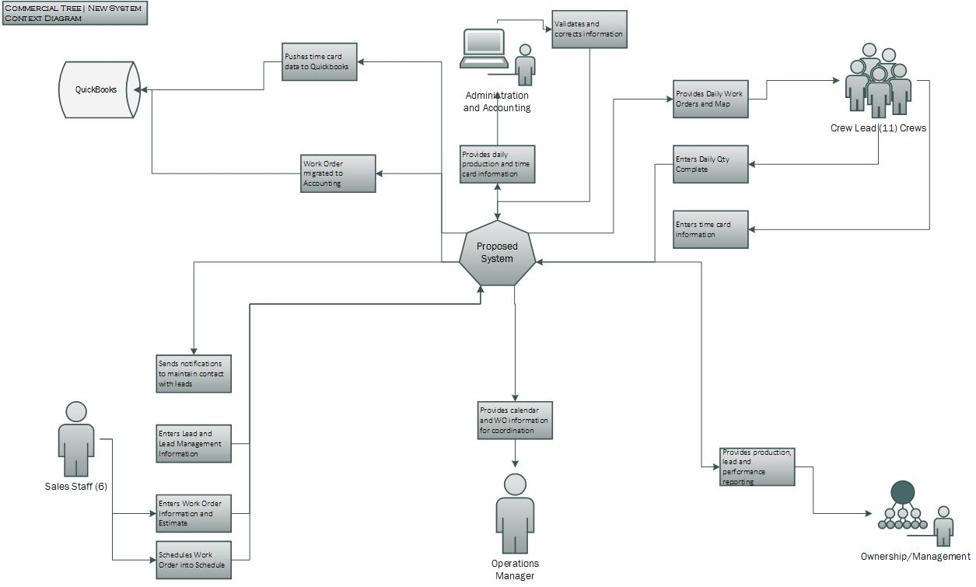

# 

# PROPOSED SOLUTIONS

The following pages will display the top two choices chosen by Commercial Tree leadership. Each solution was evaluated against the desired use of the context diagram.

## OPTION 1 | CUSTOM SOFTWARE

The system build would consist of building forms, roles, features and functionality that would replicate Commercial Tree’s day to day processes. These activities are currently managed with spreadsheets and paper on the QuickBase platform.

QuickBase is a custom platform where an organization can build their own software. QuickBase supports the data needs of any company size from small groups to entire enterprises. Your business process and needs are always evolving and so can your QuickBase apps; adapting them is easy and requires no coding or IT resources.

**Pros (In Synch with Objectives)**

* Would allow development to replicate Commercial Tree’s exact business processes
* Could add additional features and functionality as required throughout the life of the system
* Customization offers the flexibility for agile development

**Cons (Out of Synch)**

|  |  |  |  |  |  |
| --- | --- | --- | --- | --- | --- |
| **Initial Investment** |  |  |  |  |  |
| **Software** | **# of Users** | **Yearly Amount** | **Monthly Support** | **Annual Costs (Recurring)** | **First Year** |
| **COMMERCIAL TREE CUSTOM APPLICATION** |  |  |  |  |  |
| QuickBase | 20 |  | $400.00 | $4,800.00 |  |
| Integration with QuickBooks | 1 |  | $180.00 | $2,160.00 |  |
| Moby Quick | 10 |  | $100.00 | $1,200.00 |  |
| **Total:** |  | **$0.00** | **$680.00** | **$8,160.00** |  |
| **Third Party Application** |  |  |  |  |  |
| Calendar Build In |  | $5,000.00 |  | $0.00 |  |
| Time Card Signature Capture |  | $299.00 |  |  |  |
| **Total:** |  | **$5,299.00** | **$0.00** | **$0.00** |  |
| **Pricing** |  | **$5,299.00** | **$0.00** | **$8,160.00** | **$13,459.00** |
|  |  |  |  |  |  |
| **Implementation Costs** |  |  |  |  |  |
| Implementation Costs (151 Hours to Develop and Train) | | $20,385.00 |  |  |  |
| Estimated Range From Estimate (+/- Estimate) |  | 20% |  |  |  |
|  |  |  |  |  |  |
| Estimated Implementation Cost | **LOW** | $19,365.75 |  |  |  |
|  | **HIGH** | $24,462.00 |  |  |  |
|  |  |  |  |  |  |
| **Software + Implementation** | **LOW** | **$32,824.75** |  |  |  |
|  | **HIGH** | **$37,921.00** |  |  |  |

## OPTION 2 | FIELDAWARE

Field Aware is a commercially available solution used by many dispatch services industries. While not specifically designed for the tree services industry, it does mirror many of the day to day operations used by staff.

Companies with 10 to 10,000 technicians can increase profitability, generate more revenue, simplify processes and reduce customer churn with Field Aware. Multiple licensing options (as well as a leasing program) designed to meet the unique needs of companies of all sizes.

**Ariam Consulting Evaluation**

* Professional firm with a lot of documentation for their product
* A little non responsive for follow up phone calls

**Pros (In Synch with Objectives)**

* Offered a majority of features that met Commercial Tree’s requirements
* Implementation period would be considerably lower

**Cons (Out of Synch)**

* Does not offer customization; would require Commercial tree to change systems
* Subscription pricing considerably more expensive than custom solution

|  |  |  |  |  |  |
| --- | --- | --- | --- | --- | --- |
| **Initial Investment** |  |  |  |  |  |
| **Software** | **# of Users** | **Yearly Amount** | **Monthly Subscription Cost** | **Annual Costs (Recurring)** | **First Year** |
|  |  |  |  |  |  |
| Field Aware | 20 |  | $90.00 | $21,600.00 |  |
|  |  |  |  | $0.00 |  |
| **Total:** |  |  |  | **$21,600.00** |  |
| **Total:** |  |  | **$0.00** | **$0.00** |  |
|  |  |  |  |  |  |
| **Pricing** |  |  | **$1,800.00** | **$0.00** | **$21,600.00** |
| **Implementation** |  |  |  |  |  |
| Implementation Costs | Plug In # |  |  | $3,000.00 |  |  |
| Training and Guiding Transition 80 Hrs @ 150.00 |  |  | $12,000.00 |  |  |
| Estimated Implementation Cost | **LOW** |  | $12,000.00 |  |  |
|  | **HIGH** |  | $15,000.00 |  |  |
|  |  |  |  |  |  |
| **Software + Implementation** | **LOW** |  | **$33,600.00** |  |  |
|  | **HIGH** |  | **$36,600.00** |  |  |

# TOTAL COST OF OWNERSHIP

For twenty users, the cost of ownership will be considerably lower for custom solution than for Field Aware.

The following graph shows total cost of ownership over a five year period.

|  |  |  |
| --- | --- | --- |
| **Estimated Budget Amounts ERP Selection** |  |  |
| **Description** | ***Custom Solution*** | ***Field Aware*** |
| License (approx. 20 users) + First Year Investment | ***$37,921.00*** | ***$36,600.00*** |
|  |  |  |
| ***First year License + Implementation*** | ***$37,921.00*** | ***$36,600.00*** |
| Years 2-5 | ***$32,640.00*** | ***$86,400.00*** |
| Total Cost of Ownership (Five Years) | ***$70,561.00*** | ***$123,000.00*** |

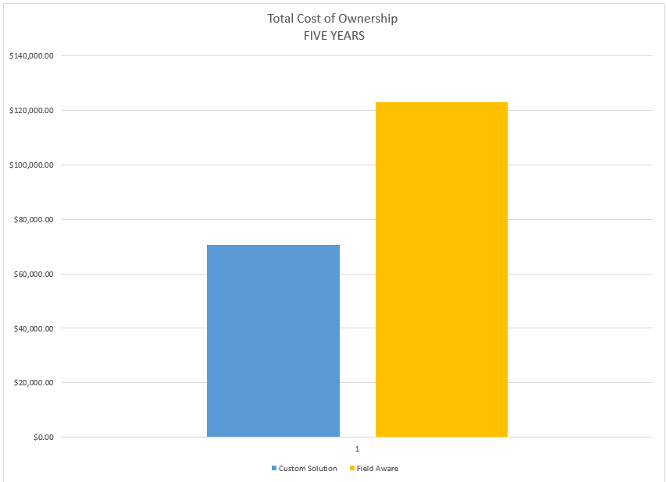

# NEXT STEPS AND PROPOSED PROJECT PHASES

Assuming leadership choses to go custom route, the following shows the proposed phase and schedule

## PROJECT PHASES

