Start Easy DMS:
Easy DMS in your Desktop
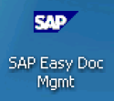
Double click the icon
Select the client, (Ex:110 SAP Dev Client)
Enter the User Name & Password (its same as ECC system)
• Note: After log in it will prompt to create “Private Root Folder” you can ignore this and go ahead.
Click AGI Public Root Folder to create and Save DMS Documents.

Easy DMS – Initial Screen

Menu Option Details of Easy DMS as follows:

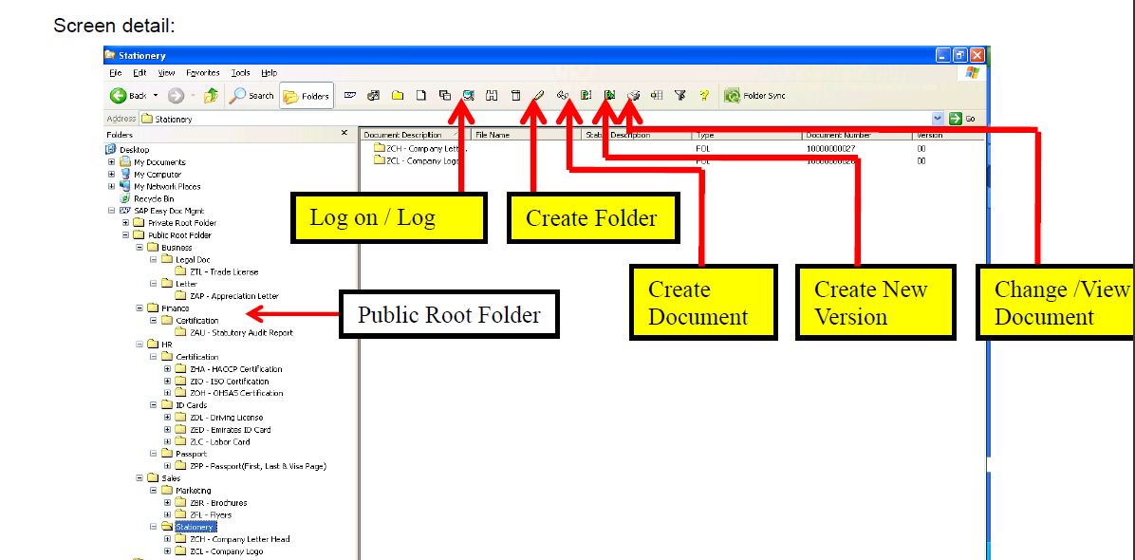

Steps to create Folder creation in Easy DMS:

Click Icon “Create Folder” to create folder

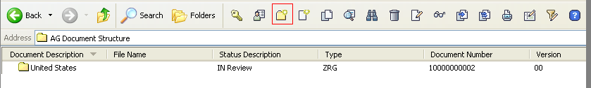

Select required document type for folder creation. Please use below guidelines to create folder creation.
Folder Types:
Region-ZRG
Year-ZYR
Month-ZMT
Remaining Folders-FOL

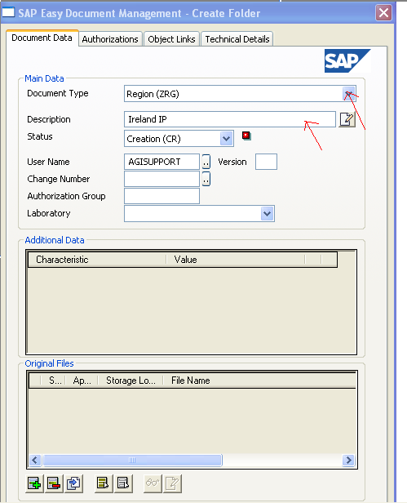
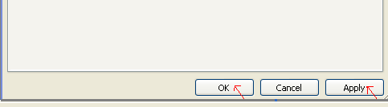

Steps to create DMS Document Creation:

Click “Create document” Menu option to create document in Easy dms

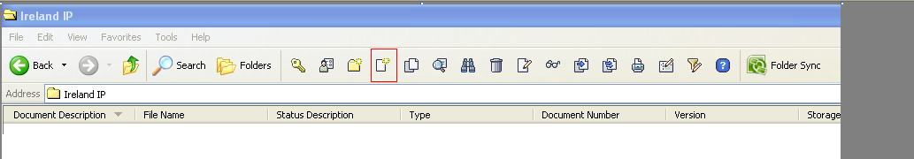

Enter the correct document type, for help check the document type by clicking dropdown list as shown below
Note: Please use only Custom document types that starts with Z*

Enter Description of DMS Document

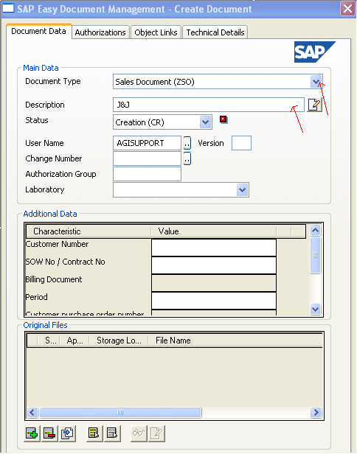
Select “Add a New File” icon to attach file to DMS Document
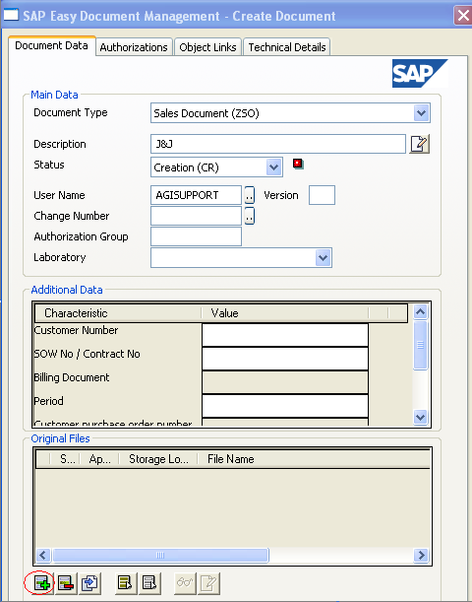

Select the required file in this case Invoice-0090300668

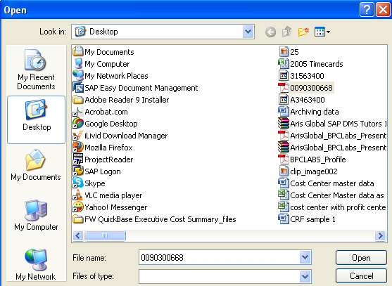
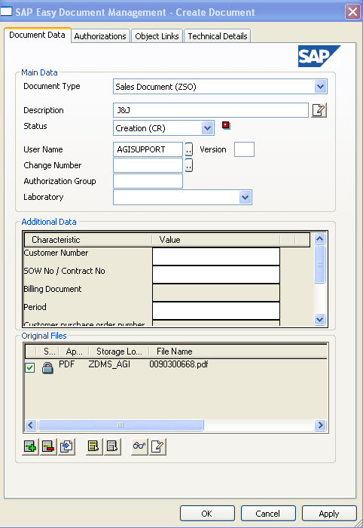

Click “Check In Selected File(S)” to copy the file in content server.
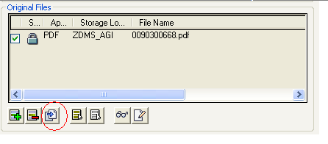
Click “Apply” and “OK” to save the changes.
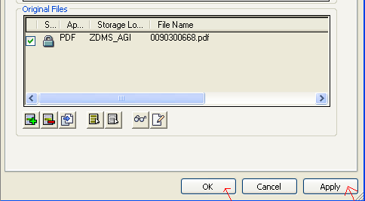

Click “SAP Properties” to attach the DMS Document to required SAP Object links.

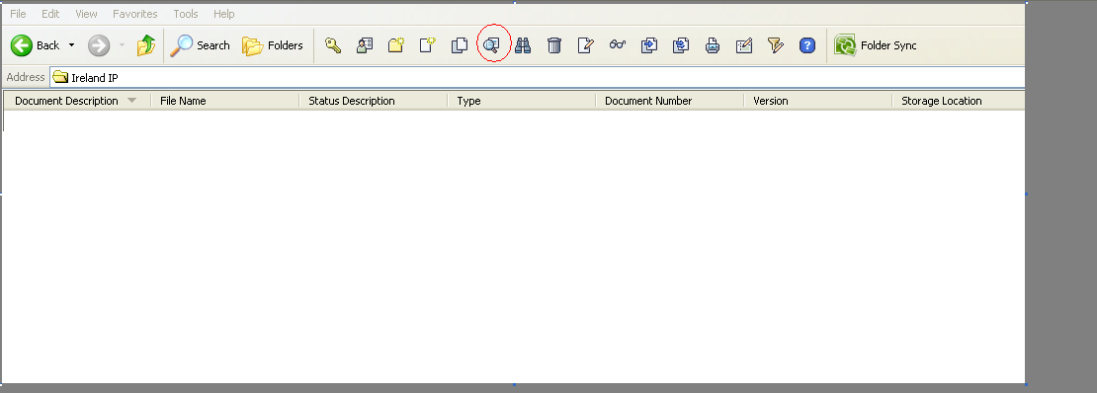

Click “Object Links” tab

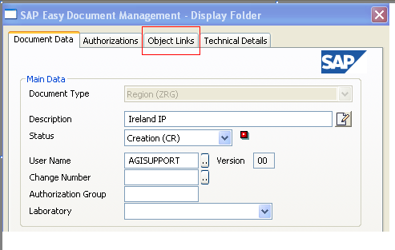

Attach the DMS Document to Respective SAP Objects like FI Document,WBS Element, Sales Document Item ,Sales Invoice.
Note: SAP Objects in Object Links tab will appear based on document type(Ex: ZSO in this case) selected.
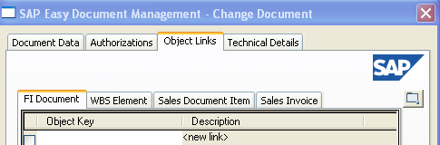

FI Document:
Use below Format while attaching finance document (via Object link) to DMS Document in Easy DMS
CCODE followed byFINANCEDOCUMENT followed by YEAR
EX:510020000002112012

Note: This format is only for FI Doc number in Easy DMS.There is no restrictions for remaining object links.

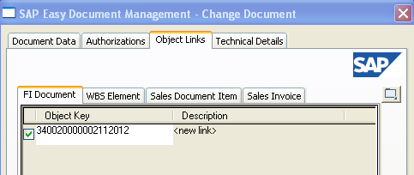

Find Object option is inactivated for most of the documents like FI Document, Sales document Item, Sales Invoice except for WBS element:
Ex: Find Object is inactivated for FI document in Easy DMS as highlighted in below screenshot.
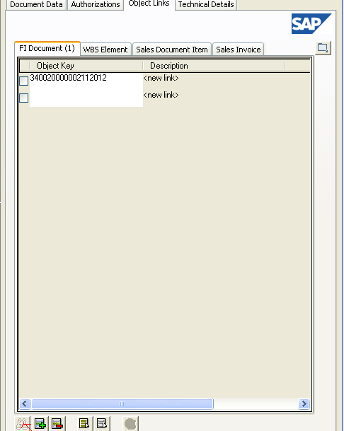

Once DMS Document is attached to file and assigned to respective SAP Objects, kindly change the status to “released”
Change Status:
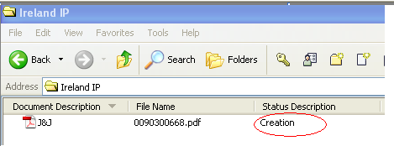
Right click on document and select “Change Status” option .It displays two options to select: Creation (CR) and IN Review (IR).Please select IN Review (IR) to change the status to In Review
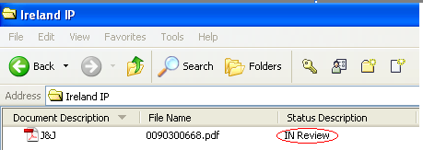
Right click on document and select “Change Status” option .It displays two options to select: Creation (CR) and Released (RE) .Please select Released (RE) to change the status to Released.
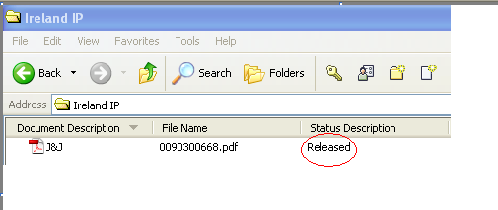
Note: If any additional file needs to be attached, please make document status as creation, attach the additional file and repeat the above change status steps.

To view DMS document (created in SAP R/3) in Easy dms.
1. Consider some created dms document as shown below:
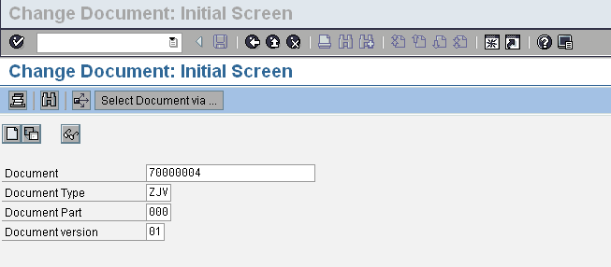
2.Requirement to view the above dms document in below easy dms folder.
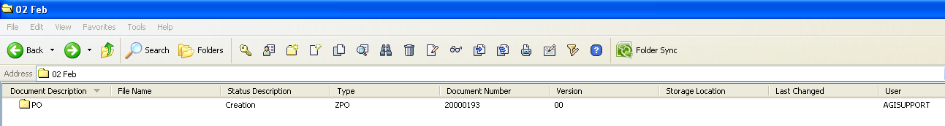
This folder”PO” contains no dms document yet.
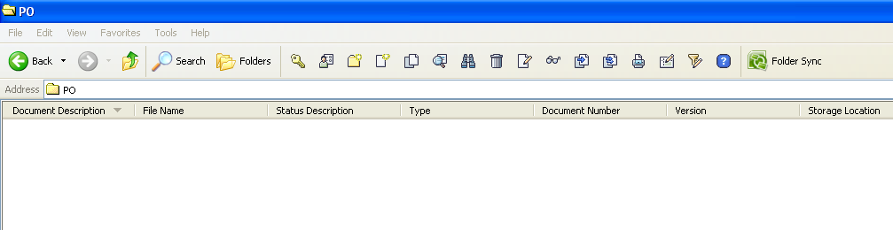

Copy the “PO” folder document number and document type and paste it in transaction code CV12 in SAP R/3
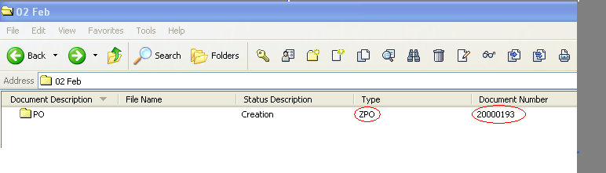

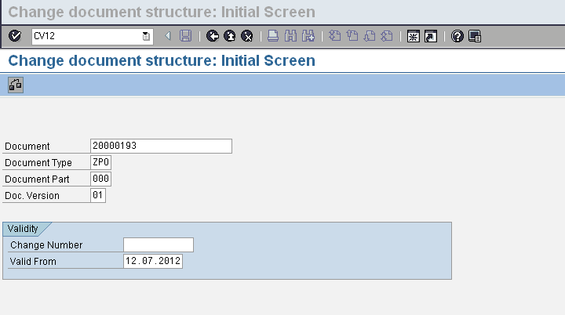
Click enter icon
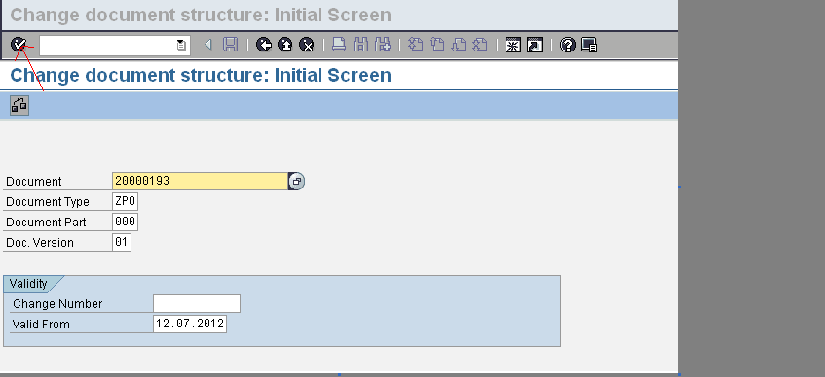
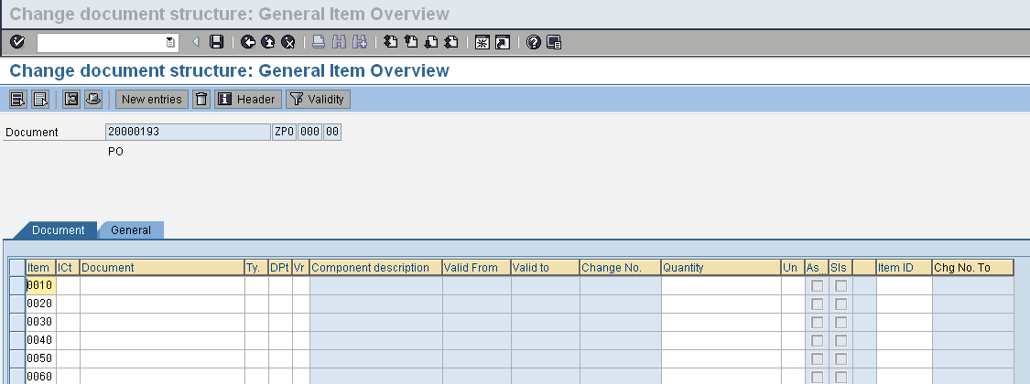

Enter “DMS Document “to view in this folder in Easy dms.
Always enter “d” as item category, document as 70000004 and document type as ZJV (sample example),click “save” icon” to save the dms document in “20000193” folder.
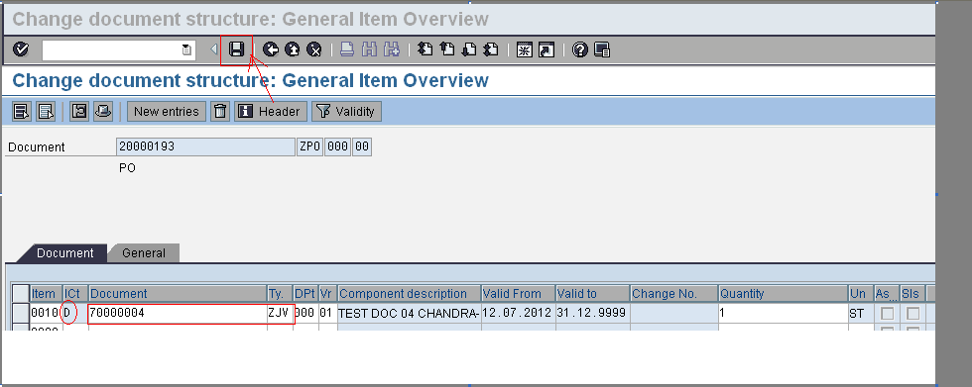

Now we can able to view the same document in 20000193 folder in easy dms
