ServiceNow Board. Task Board
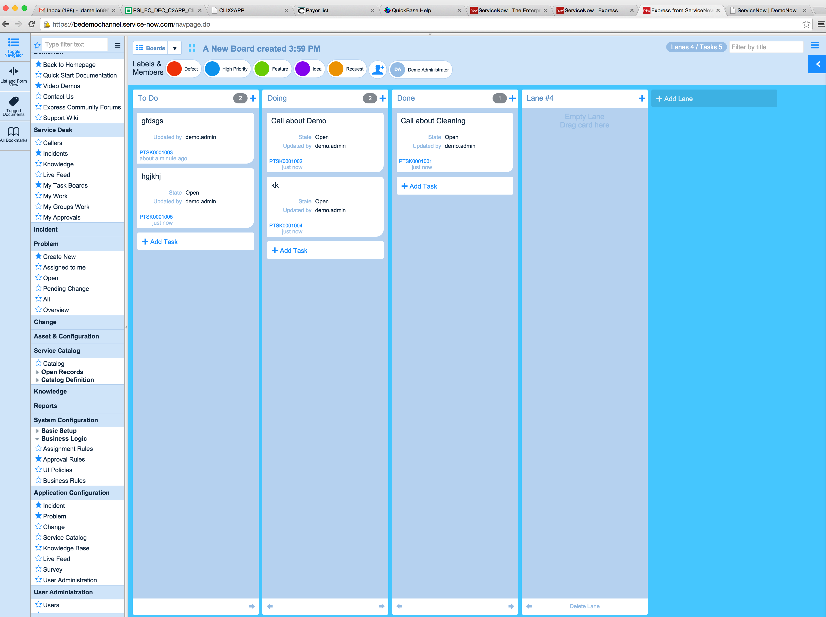

https://bedemochannel.service-now.com/navpage.do

